 

INSTITUTE FOR ADVANCED COMPUTING AND SOFTWARE DEVELOPMENT AKURDI, PUNE

Documentation On

**“EGaming portal”**

PG-DAC FEB-2020

*Submitted By:*

**Group No: 92 Names & roll numbers**

**1137_Harshad Dodake**

**1157_Lalit Chaudhary**

**Mr. Prashant Karhale Mr. Akshay Parab**

**Centre Coordinator -Project Guide**

# Table of Contents

1. Introduction 5

Document Purpose 5

Problem Statement 6

Product Scope 6

Aim & Objectives 6

1. Overall Description 7

Product Perspective 7

Existing System Function 7

Maintainance Manager 7

benefit of E-Gaming Portal 8

User Charecteristics 8

1. Requirements Specification 9

External Interface Requirements 9

Design amd Implementation Constraint…………………………………………………10

**4.Specific Interface…………………………………………………………………………...11**

User Interface Requirment…….……...………………………………………………...11

User Interfcae…………………………………………………………………………..11

Hardware Interface……………………………………………………………………..11

Application Interface…………………………………………………………………...11

5.**System Diagram 12**

Activity Diagram 13

Data Flow Diagram 13

Flow diagram…………………………………………………………………………...14

Class Diagram 14

Use Case Diagram 14

ER Diagram 16

6.Table Structure 17

User table 17

admin Table 17

Order Table 17

**7.Screenshots………………………………………………………………………………...18**

User Login…………………………………………………………………………………18

Registration………………………………………………………………………………..18

**8.Customer Login………………………………………………………………………………..19**

**9.Admin Functionalty…………………………………………………………………………....20**

**10.Adding category………………………………………………………………………………..21**

Games……………………………………………………………………………………….22

11.Conclusion …………………………………………………………………………………….23

Future Scope ……………………………………………………………………………….23

Refrence……………………………………………………………………………………23

Online Refrence…………………………………………………………………………...23

**List of Figures**

Figure 4 Level 0 Data Flow Diagram 13

Figure 5 Level 1 Data Flow Diagram 13

Figure 6 Level 2 Data Flow Diagram for Admin 14

Figure 9 Class Diagram 15

Figure 10 Use Case Diagram 16

Figure 11 ER Diagram 16

1. **Abstraction**

This project is aimed at developing a website for buying all category gaming. The E-Gaming Portal provides an easy interface that would let the users to get games. It provides the users more pleasure and gladdening his mind by buying these games such as Action ,Racing ,Adventurous games. E-Gaming Portal is also providing best games in very cheap price that users can buy games in different categories.

**Document Purpose**

The system will be used for providing online game purchasing. Now in day to day life so many people buy games from shop and waste their time in doing this but now using E-Gaming Portal we can purchase games within a minute and people can enjoy playing these games.

Enhance E-Gaming Processes:

To be able to use internet technology to buy many games online on world wide domain, thus decreases their physically purchasing games time.

E-Gaming Portal Services:

A website through which admin can add all Games and provide them for people. The admin also receives some set of functionalities which help in managing the E-Gaming application.

Bill generation:

This system’s key functionality is that it helps in generating the bill of the Purchased games.

**Problem Statement**

Existing system for a E-Gaming is based on our traditional way of going to shop and purchasing games and doing so much bargaining with them. It is hard to do all this work and also wastage of time too. Hence this system is proposed to overcome the all flaws of the existing system and giving power to the admin of the E-Gaming so that he/she will be able to get gaming easily.

**Product Scope**

This project traverses a world wide areas ranging from business concept to computing field, and required to perform several researches to be able to achieve the project objectives. The area covers include:

* The use of the system for better services and fast processing.
* E-Gaming facility in India is very Higher and maximum charges but we can give all Category games in minimum charges with best quality.
* J2EE Technology used for the development of the application.
* Web-platform means that the system will be available for access 24/7 except when there is a temporary server issue which is expected to be minimal.

**Aims & Objectives**

Specific goals are: -

* The main objective of the E-Gaming Portal is for all gaming fans to get their favourite games in cheaper and best quality.
* To build an application program to reduce the manual work for purchasing Games.
* Main motive is “pay and Play” best quality and ver cheap games.

**2.Overall Description**

**Product Perspective:**

**Existing system function:**

The existing is automated only to a particular extent they does lot of manual work.

The existing system involves several processes like,

* Wastage of time in physical purchasing, lots of prices ,No quality assurance
* The user has to reach gaming shop to get their respective game.
* There is no optimal way of getting games easily. It saves a lot of time, money.

.

*Maintenance Manager:*

The project helps the administrator to generate monthly bill based on various sold games and maintaining the quality of Portal and security.

**Benefits of E-Gaming Portal-**

* This application is fully functional and flexible.
* It is very easy to use.
* It saves a lot of time, money and labour work.
* E-Gaming Portal will help you to get best quality games in low prices.
* Using software solutions for E-Gaming gives the complete visibility over their operations to the companies.
* This application is available at customer service.
* Admin can provide customer service.
* It increases the efficiency of the management at offering quality games to the customers.

**Users and Characteristics:**

Admin:

* Admin can login to the system.
* View the list of all users.
* Add new games.
* Delete user.
* Update games.
* View the list of all customers.
* View all reviews.

**Operating Environment:**

Server Side:

**Processor:** Intel® Xeon® processor 3500 series

**HDD:** Minimum 500GB Disk Space

**RAM:** Minimum 4GB

**OS:** Windows 8.1

**Database:** MySQL

Client Side (minimum requirement):

**Processor:** Intel Dual Core

**HDD:** Minimum 80GB Disk Space

**RAM:** Minimum 4GB

**OS:**Windows7

**Design and Implementation Constraints:**

* This web application developed using J2SE, J2EE, JDBC, MySQL and Hibernate as ORM tool and bootstrap for user interface.
* HTTP and FTP protocols are used as communication protocols. FTP is used to upload the web application in live domain and the client can access it via HTTP protocol.
* Several types of validations make this web application a secured one and SQL Injections can also be prevented.
* Since Package Delivery Service is a web-based application, internet connection must be established.
* The Package Delivery Service will be used on PCs and will function via internet or intranet in any web browser.

**3.Specific Requirement**

**External Interface Requirements:**

User Interfaces:

* All the users will see the same page when they enter in this website. This page asks the users a username and a password.
* After being authenticated by correct username and password, user will be redirect to their corresponding profile where they can do various activities.
* The user interface will be simple and consistence, using terminology commonly understood by intended users of the system. The system will have simple interface, compatible with standard interface, to eliminate need for user training of infrequent users.

Hardware Interfaces:

* No extra hardware interfaces are needed.
* The system will use the standard hardware and data communication resources.
* This includes, but not limited to, general network connection at the server/hosting site, network server and network management tools.

Application Interfaces:

**OS:** Windows 7

**Web Browser:**

The system is a web-based application; clients need a modern web browser such as Mozilla Firebox, Internet Explorer, Opera, and Chrome. The computer must have an Internet connection in order to be able to access the system.

Communication Interfaces:

* This system uses communication resources which includes but not limited to, HTTP protocol for communication with the web browser and web server and TCP/IP network protocol with HTTP protocol.
* This application will communicate with the database that holds all the booking information. Users can contact with server side through HTTP protocol by means of a function that is called HTTP Service. This function allows the application to use the data retrieved by server to fulfil the request fired by the user.

**4.System Diagram**

**Data Flow Diagram**

**Admin**

**Website**

**User**

**Figure 4: Level 0 Data Flow Diagram**

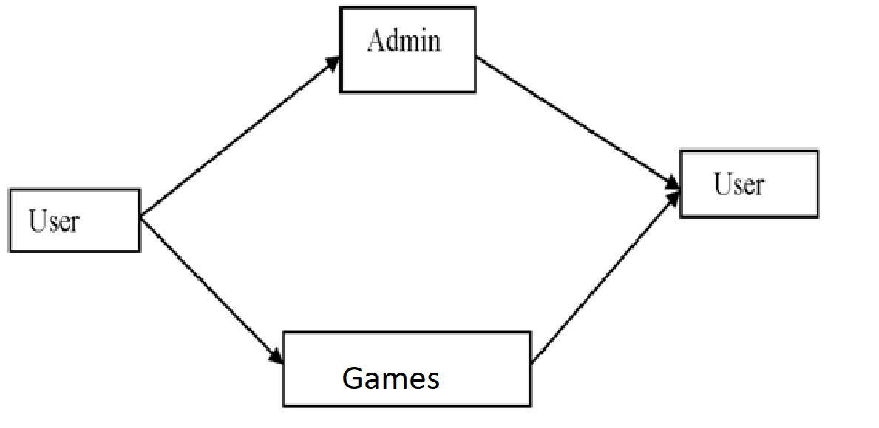

**Figure 5: Level 1 Data Flow Diagram**



**Figure 6: Level 2 Data Flow Diagram for Admin**

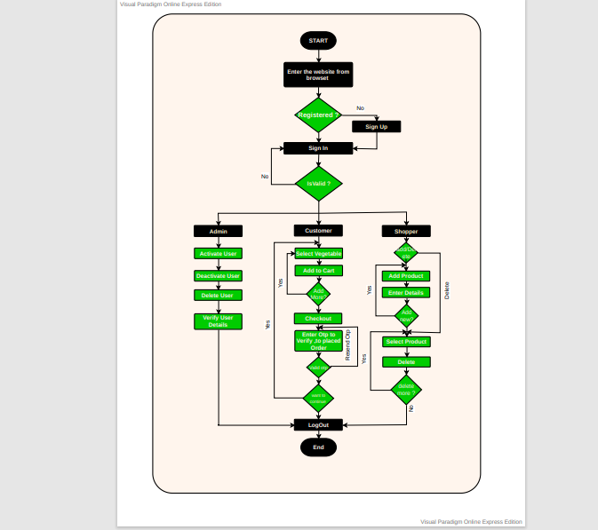**Figure 7:Flow Diagram**

**Use Case Diagram**

10.UML Diagram

**ERD Diagram**

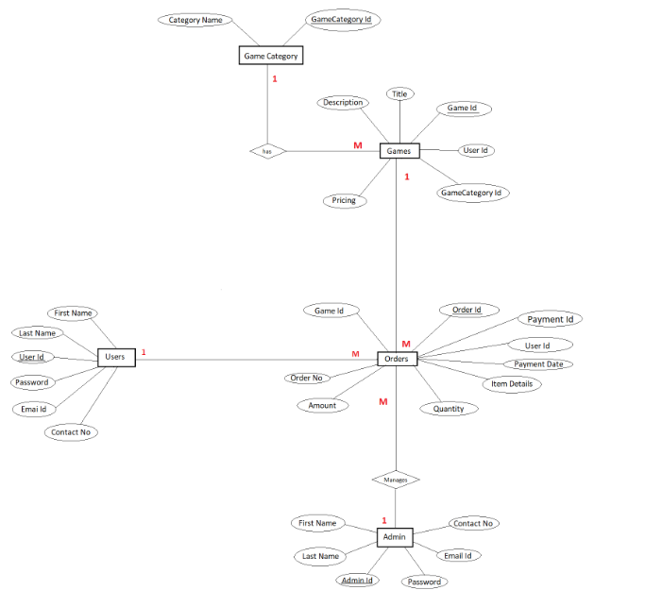

**11.ERD Diagram**

**5.Table Structure**

**User:**

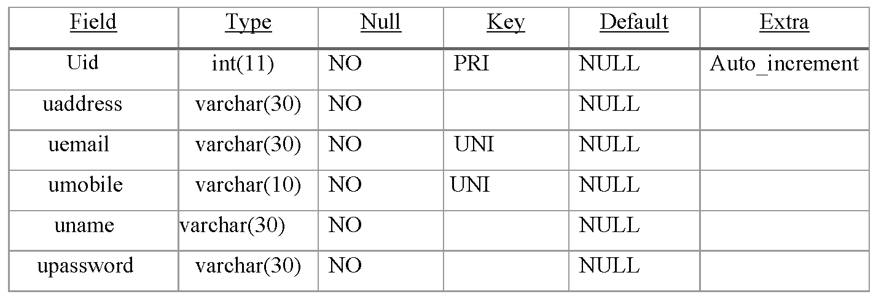

**Admin:**

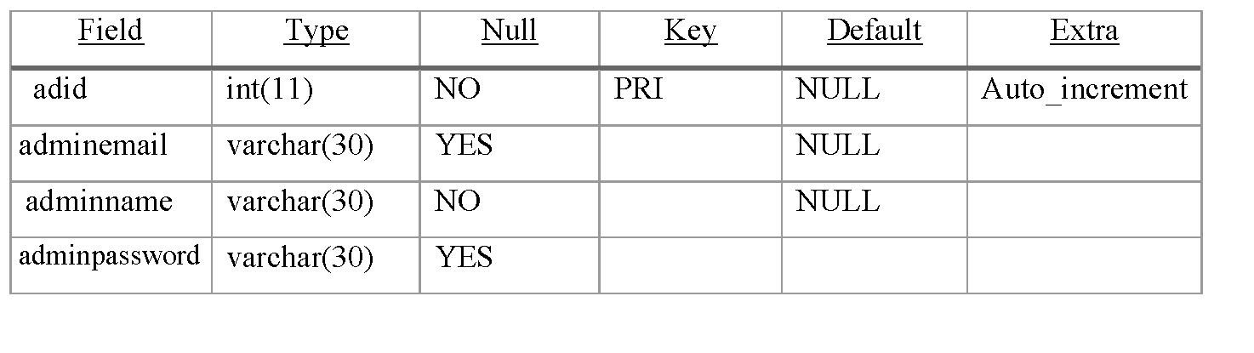

**Order:**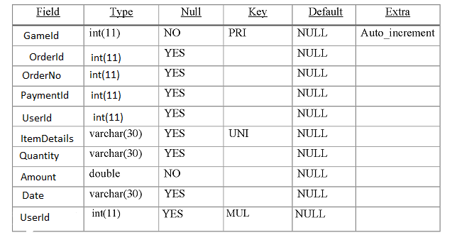

**6. Screenshots**

**User Login:**

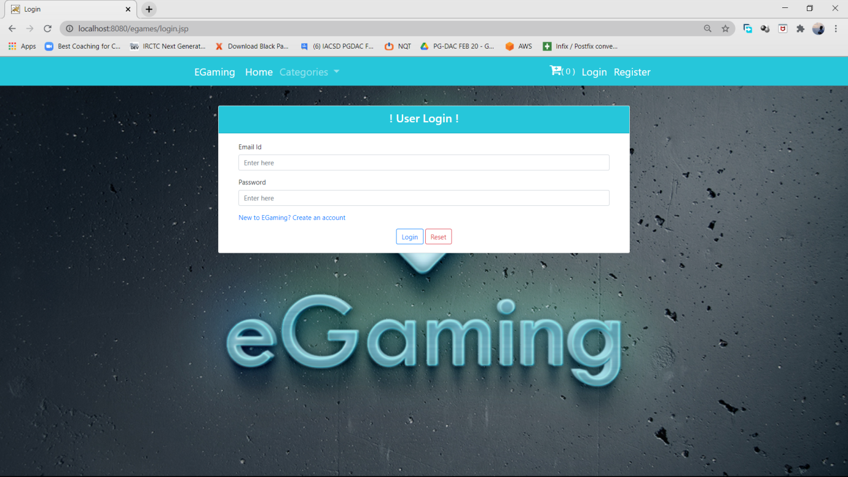

**Login Authentication:**

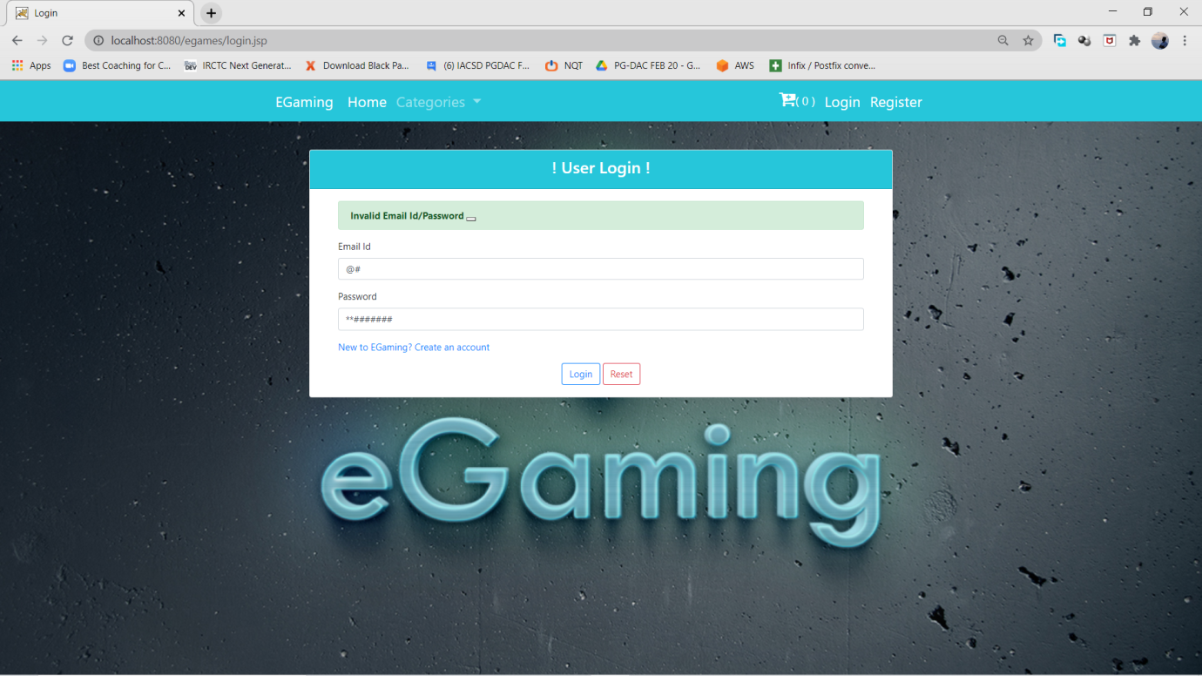

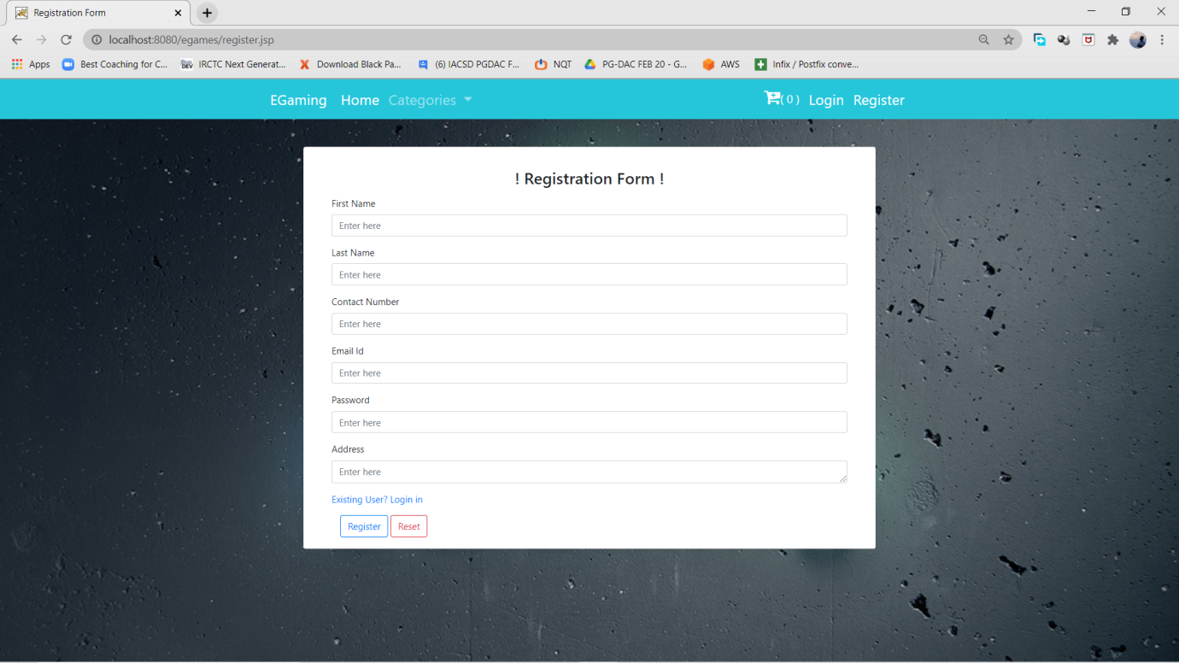**Registration:**

**Admin Funtionality:**

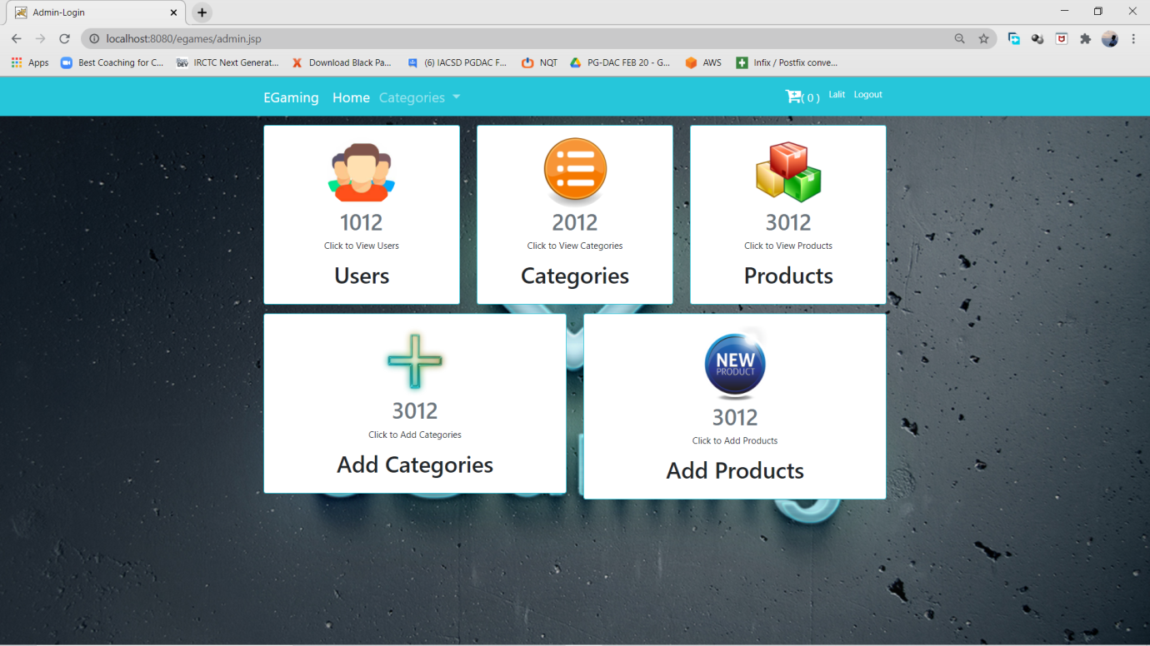

Adding Product:

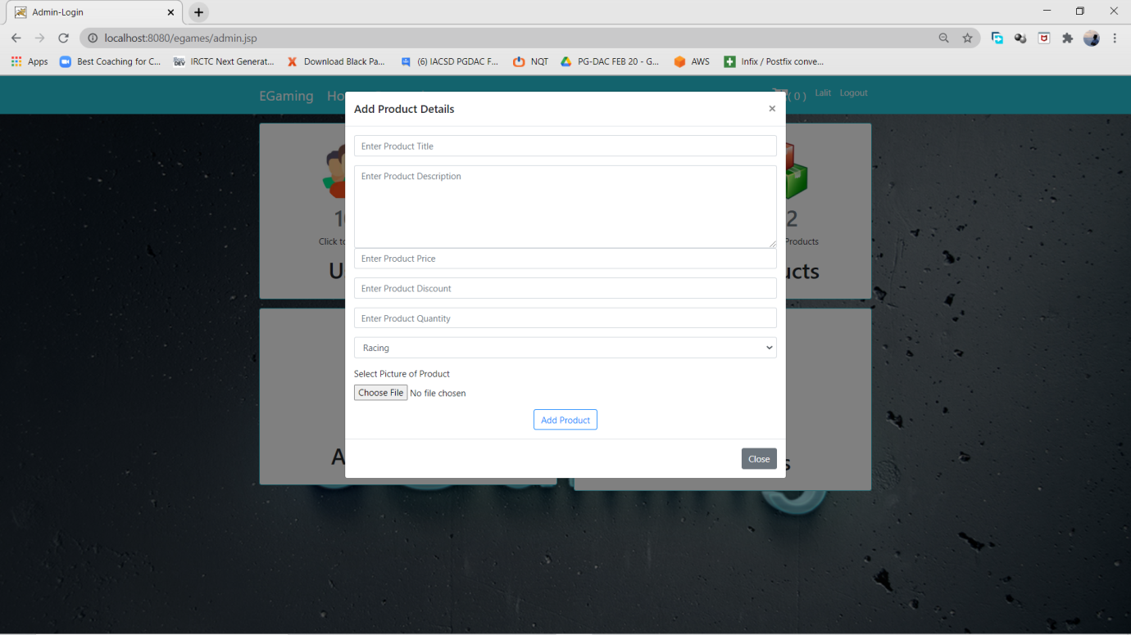

**Adding Category:**

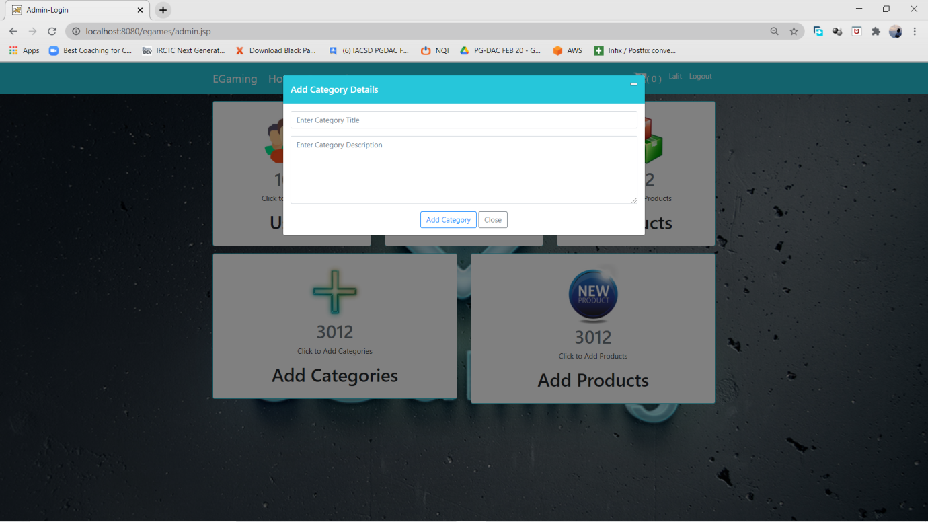

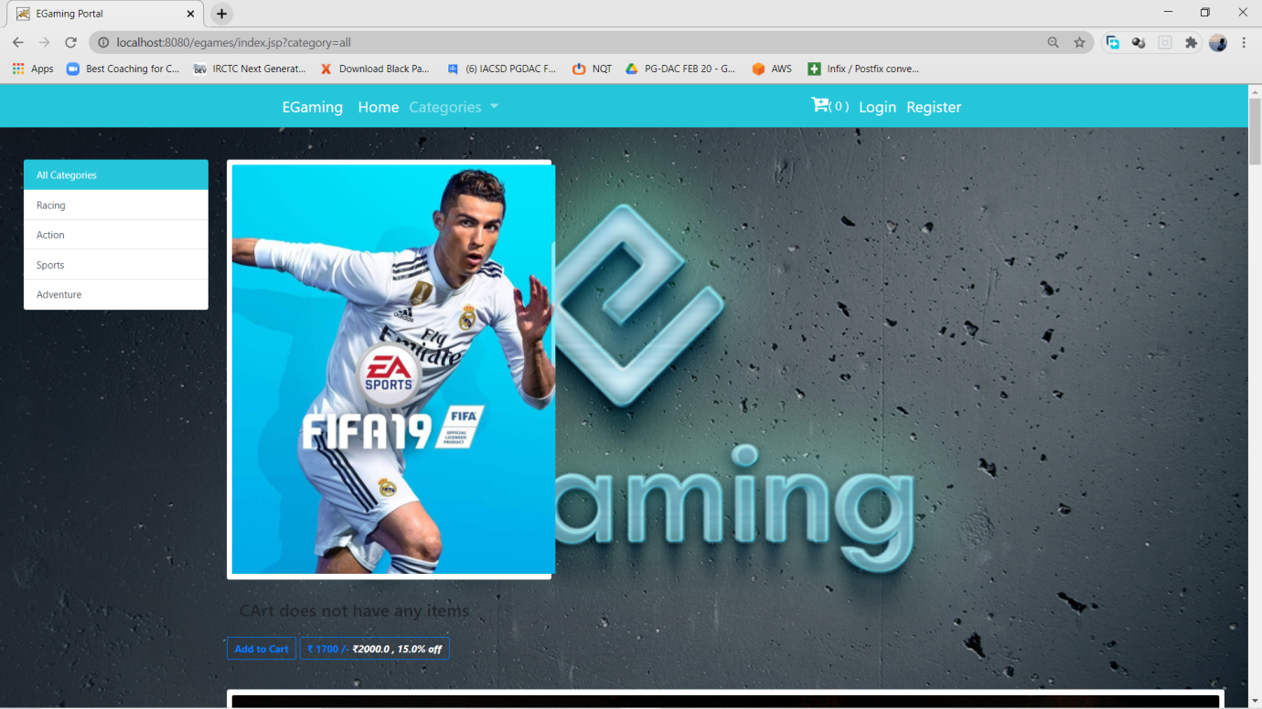**Games:**

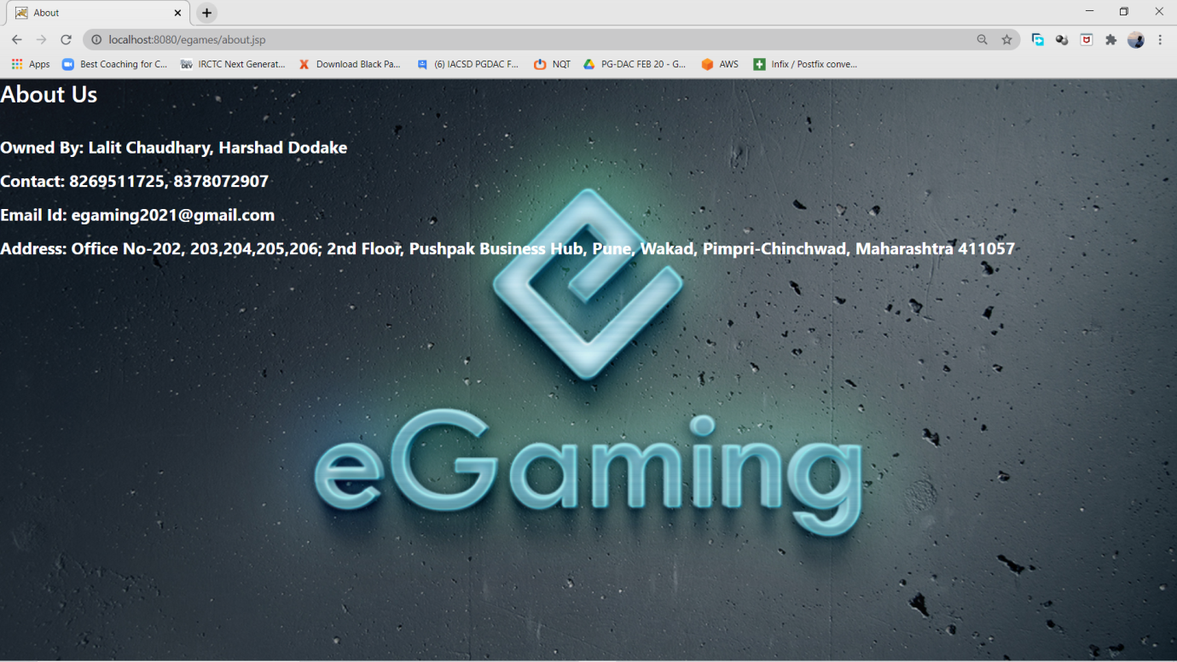

**About:**

**7.Conclusion**

This system is a user friendly and GUI based website. It satisfies all the requirements of the proposed system to a great extent. This system is developed in a way that it is easy to use and easy to maintain. This system is mainly designed to reduce the cost, to increase the experience of the customer and to increase the operational efficiency. The system is developed to help the customer to find the location of the package. It helps them to know the package departure status. This added feature makes the user to conveniently use the system.

**Future Scope**

This project can be enhanced further by adding Many more Games in it. The software is flexible enough to be modified and implemented as per future requirements. We have tried our best to present this free and user–friendly website to the customers.

**8. References**

**ONLINE REFERENCE**

* www.Bootstrap4.com
* www.FreeProject.com
* <https://github.com/ChetanBhogade/E-Commerce-Project>
* https://code.jquery.com/
* Learning spring boot, angular and MySQL to create responsive website.
* Javatpoint website for core java concepts.
* Tutorials point website for learning MySQL.